Software Requirement Specifications
<Online Course Registration>



Submitted by
Muhammad Ali (F24BINFT7M04014)

Submitted to
Ma’am Kainat

Department of Information Technology
Faculty of Computing
The Islamia University of Bahawalpur

Meeting Details
Sr No | Details | Date | Supervisor Signature
Summary
The Software Requirements Specification (SRS) for the Online Course Registration System outlines the complete functional and non-functional needs for developing an efficient, user-friendly, and secure digital platform for course enrollment. The system allows students to create accounts, log in, browse available courses, check prerequisites, register or drop courses, and make online payments. It also provides administrators with tools to manage courses, schedules, instructors, and student records.
The SRS defines key functional modules such as course browsing, filtering, enrollment, payment processing, seat management, and viewing registered courses. Non-functional requirements ensure the system’s performance, reliability, scalability, security, and usability across devices. The document further describes essential use cases, including user registration, course selection, enrollment workflows, and payment procedures.
Overall, the SRS ensures a clear roadmap for developers, testers, and stakeholders to build a robust and automated course registration platform that replaces manual processes and delivers a seamless experience for students and administrators.

Table of Contents
1. Introduction 4
1.1. Purpose 4
1.2. Scope 4
1.3. Product Perspective 4
1.4. User Characteristics 4
1.5. Similar apps and systems/Literature Review 4
1.6. Proposed Technologies 4
2. Requirements 5
2.1. Function Requirements 5
2.1.1. Sign Up 5
2.2. Non-Functional Requirements 5
3. Use Cases and Flow of Processes 6
3.1. Use Case 1 7
4. References 8

- Introduction
The Online Course Registration System is designed to provide a simple, efficient, and automated way for students to browse, select, and enroll in courses offered by an educational institution. Traditional manual registration processes often lead to long waiting times, errors, schedule conflicts, and difficulty in tracking course availability. This system addresses these issues by providing a centralized digital platform that allows students to complete the entire registration process online.
The system enables students to view available courses, check prerequisites, register or drop courses, make payments, and access their academic schedule from any device. It also offers administrative tools for managing course offerings, instructor assignments, and student registration records. By reducing paperwork and human error, the Online Course Registration System enhances accuracy, transparency, and user convenience.

1. Purpose
The purpose of this SRS is to define the complete set of requirements for the Online Course Registration System. The document will guide developers, testers, and stakeholders in building a platform where students can browse courses, register, manage their profile, pay fees, and view their enrolled courses.
  - Scope
The Online Course Registration System allows users to:
- Create and manage accounts
- View available courses
- Register for desired courses
- Make online payments
- Track registered courses
- Receive schedule-related notifications
The system is intended for universities, colleges, training institutes, and e-learning platforms.

Product Perspective
The system functions as an online platform accessible through a web browser or mobile device. It connects:
- Students (front-end users)
- Course administration (back-end)
- Database (stores courses, users, schedules)
It is a new, centralized, digital replacement for manual, paper-based course registration.
  - User Characteristics
• Students: Basic computer/mobile skills can browse and register courses.
• Admins: Intermediate technical skills for managing course catalog and student data.
• Teachers: Basic skills to update course content and schedules.

  - Similar apps and systems/Literature Review
Similar platforms include:
- Courser
- edX
- Udemy
- University course registration portals
these systems inspired the need for automated enrollment, real-time course availability, and digital tracking.

  - Proposed Technologies
• Front-end: HTML, CSS, and JavaScript
• Back-end: Python / PHP / Node.js
• Database: MySQL / SQL Server
• Security: HTTPS, JWT authentication
• Optional: C++ for scheduling algorithms or performance modules

- Requirements
  - Function Requirements

FR1: User Registration
- The system shall allow new users (students) to create an account using name, email, password, and student ID.
- The system shall validate that the email and student ID are unique.
- The system shall send a verification email after registration.

FR2: User Login
- The system shall allow users to log in using their registered credentials.
- The system shall validate the login information before granting access.
- The system shall display an error message for incorrect credentials.

FR3: View Course Catalog
- The system shall display a list of all available courses.
- Each course shall include:
  - Course name
  - Course code
  - Instructor
  - Credit hours
  - Prerequisites
  - Schedule
  - Available seats

FR4: Course Search & Filter
- The system shall allow users to search courses by:
  - Name
  - Course code
  - Department
  - Instructor
- The system shall allow filtering by:
  - Credit hours
  - Schedule
  - Availability

FR5: Course Enrollment
- The system shall allow users to enroll in a course if:
  - Seats are available
  - Prerequisites are met
  - There is no schedule conflict
- The system shall update seat availability in real time.

FR6: Course Drop/Withdraw
- The system shall allow users to drop a course during the allowed period.
- The system shall automatically update the number of available seats.

FR7: Payment Module
- The system shall allow users to pay course fees online.
- The system shall support payment methods such as credit/debit card or bank transfer.
- The system shall generate and store payment receipts.

FR8: View Registered Courses
- The system shall allow users to view all their enrolled courses in a dashboard.
- The system shall show schedule details, credit hours, and instructor information.

FR9: Admin Course Management
- Admins shall be able to add, update, and delete course information.
- Admins shall update seat limits, schedules, and instructor assignments.
- Admins shall approve or reject course registrations when needed.

FR10: Notifications & Alerts
- The system shall send notifications for:
  - Successful enrollment
  - Payment confirmation
  - Course drop deadlines
  - Schedule changes

    - Sign Up
- Name: user ID
- Purpose: The sign-up process is required for a new student or admin to create an account and become a registered member of the Online Course Registration System.
User(s): •Student, Admin
Input: • Full Name: Actual legal name of the user.
• Email: Valid email address for verification.
• Password: Must be 8+ characters long and include at least one number.
• Student ID (for students): Unique university-issued ID.
• Department: The academic department or program (e.g., CS, IT, Business).
• Phone Number: Valid mobile number for receiving notifications.
• Profile Picture (optional): Recent photo of the user.
• Account Approval (for Admin account creation only): Super Admin verifies and approves Ad
Output:
- A successfully registered user is added to the system and becomes able to log in and access their dashboard.
Min account.

  - Non-Functional Requirements

NFR1: Security
- All user data shall be encrypted.
- Passwords shall be stored using hashing.

NFR2: Performance
- Pages shall load within 3 seconds.
- The system shall support 10,000 concurrent users.

NFR3: Reliability
- The system shall maintain 99% uptime.
- Database backups shall occur daily.

NFR4: Usability
- The interface shall be intuitive and user-friendly.
- The system shall support desktop and mobile browsers.

NFR5: Scalability
- The system shall support growth in number of users and courses without performance loss.

NFR6: Maintainability
- The codebase shall be modular and documented.

- Use Cases and Flow of Processes

Use Case 1: User Registration
Actors: Student
Description: Student creates an account.
Basic Flow:
- User opens registration page
- Enters required details
- Submits form
- System validates details
- Account created

Use Case 2: Course Browsing
Actors: Student
Description: Student views available courses.
Basic Flow:
- User navigates to course catalog
- System displays course list
- User filters or searches
- User views course details

Use Case 3: Course Enrollment
Actors: Student
Basic Flow:
- User selects a course
- System checks prerequisites
- System checks seat availability
- User confirms enrollment
- System updates records

Use Case 4: Payment
Actors: Student
Basic Flow:
- User opens payment module
- Enters payment details
- System processes payment
- Receipt generated

Use Case 5: View Registered Courses
Actors: Student
Basic Flow:
- User opens dashboard
- System displays list of registered courses
- User views schedules and instructor details

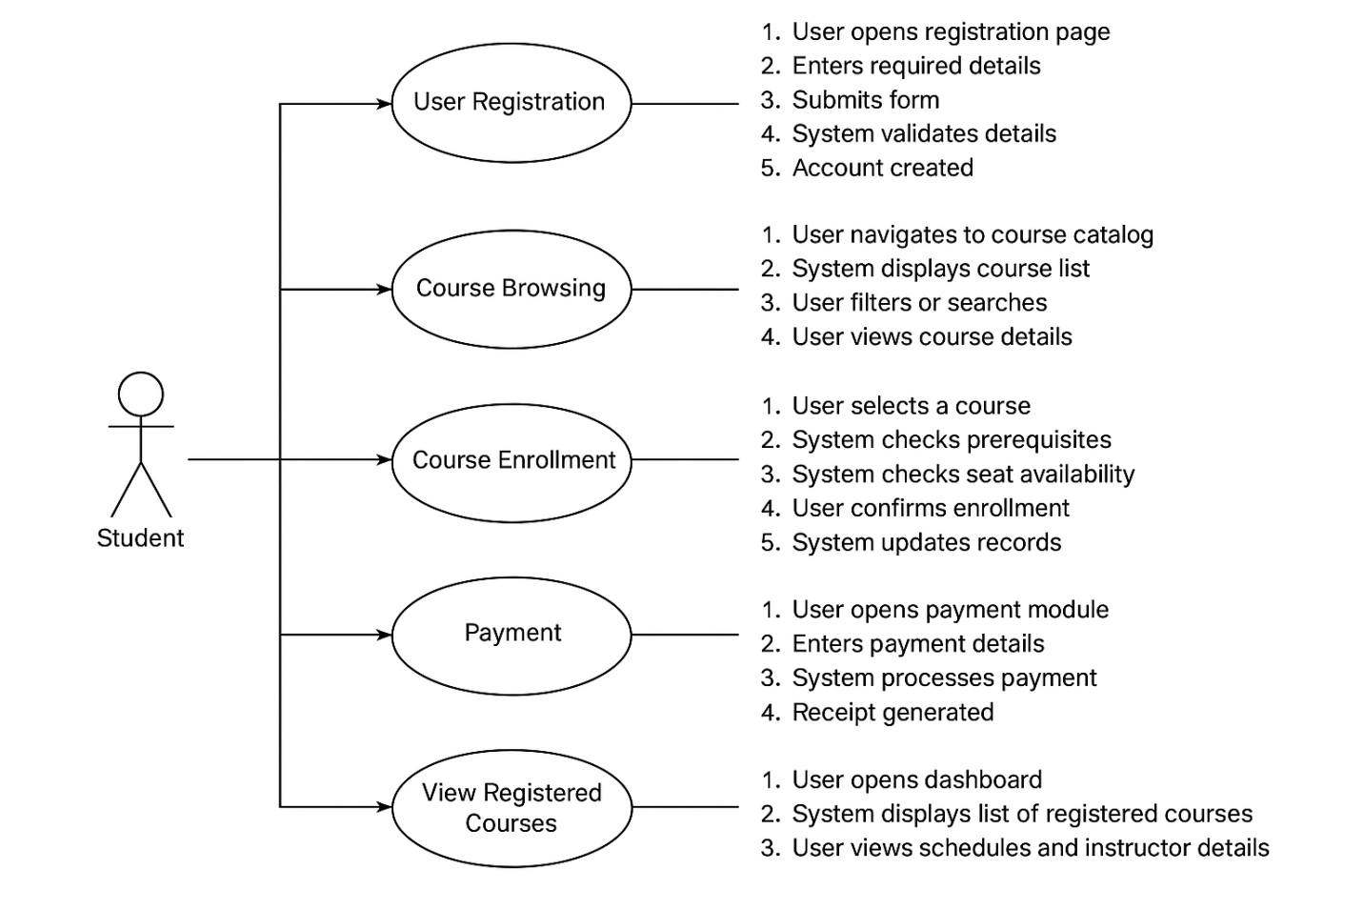
Figure 1: System Level Use Case Diagram

  - Use Case 1
ID | User ID
Name | Sign Up
Description | This use case describes the process of creating a new user account in the Online Course Registration System.
Requirement(s) | User Sign Up
Actor(s) | • Student  • Admin
Precondition | The user must not already have an account in the system
Post condition | • A new user account is created.  • The user receives a confirmation message or approval status (for Admin accounts, approval by Super Admin may be required).
Basic Flow | Basic Flow  • User opens the Sign-Up page.  • User enters required credentials.  2.1. Required fields include:  - Full Name  - Email  - Password  - Address  - Phone Number  • System validates the inputs.  3.1. Validation checks include:  - Email format must be valid  - Password must be at least 8 characters and include a number  - Phone number must contain exactly 11 digits  • If validation succeeds, the system creates a new user account.  • System displays a success message (and approval pending message for Admins).  Alternative Flow  AF-1: Admin Creates a User  - Admin logs into the system.  - Admin opens the “Create User” page.  - Admin enters user details on behalf of a student or staff member.  - System validates and creates the account.  Exceptions  - Invalid Inputs  - Missing required fields  - Invalid email format  - Weak password  - Incorrect phone number format  → System shows error messages and prevents account creation.  - System Unable to Respond  - Server error  - Network failure  → System displays a failure message and asks user to try again later.
Diagrams
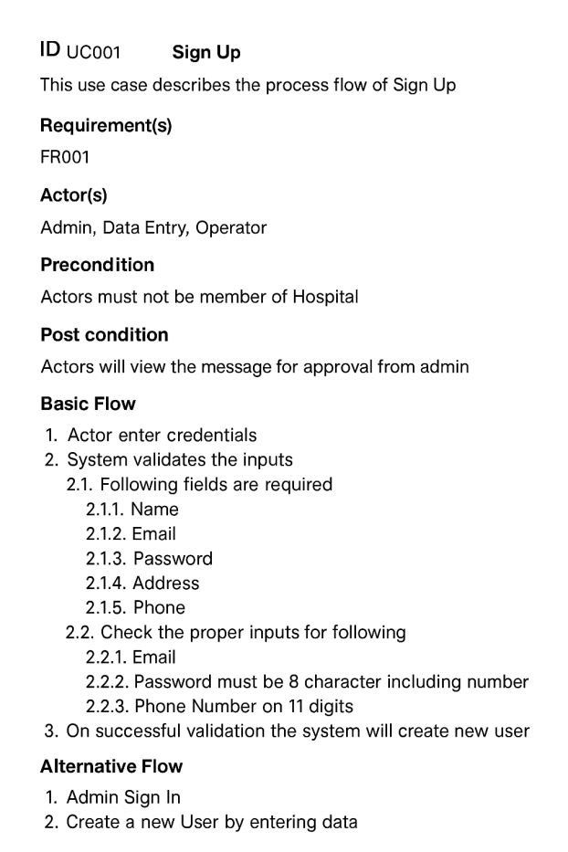
3.2References

Books
- Sommerville, I. (2016). Software Engineering (10th Ed.). Pearson Education.
- Pressman, R. S., & Maxim, B. R. (2020). Software Engineering: A Practitioner’s Approach (9th Ed.). McGraw-Hill.
- Shelly, G. B., & Rosenblatt, H. J. (2012). Systems Analysis and Design. Cengage Learning.
- Laudon, K. C., & Laudon, J. P. (2018). Management Information Systems (15th ed.). Pearson.

Journals & Research Papers
- Al-Rahmi, W. M., et al. (2018). “The role of e-learning in higher education: Empirical study.” Education and Information Technologies, Springer.
- Sun, P. C., et al. (2008). “What drives a successful e-Learning? An empirical investigation.” Computers & Education, Elsevier.

Web Resources
- IEEE. (2020). IEEE Recommended Practice for Software Requirements Specifications. IEEE Standards.
- Moodle Documentation. (2024). Course Enrollment and Registration Guide.
- Courser Help Center. (2024). How Enrollment Works in Online Courses.
- EdX Support. (2024). Enrollment and Course Access Guidelines.

Project / System References
- Khan Academy. (2024). About Our Learning Platform.
- Udemy Business. (2024). Course Enrollment Process Overview.

General SRS & SDLC References
- ISO/IEC/IEEE 29148:2018 – Systems and software engineering — Life cycle processes — Requirements engineering.
- Object Management Group. (2017). Unified Modeling Language (UML) Specification.

